LoRa Tutorial

# Overview

In this tutorial, we will interconnect an Arduino board with a Raspberry Pi one throw LoRa modules. Here is an illustration of the infrastructure we will implement.

In the first step of this tutorial, we will configure a Raspberry Pi as a gateway to receive LoRa message from an Arduino board.

# Raspberry Pi as a gateway

## Hardware

To add XBee functionality to Raspberry Pi 2 or 3, we use the following hardware: “[Raspberry Pi to Arduino Shields Connection Bridge](https://www.cooking-hacks.com/raspberry-pi-to-arduino-shield-connection-bridge)” and a “[SX1272 LoRa module](https://www.cooking-hacks.com/sx1272-lora-module-for-arduino-raspberry-pi-intel-galileo-868-mhz)”. You can find a [tutorial made by Cooking Hacks](https://www.cooking-hacks.com/documentation/tutorials/extreme-range-lora-sx1272-module-shield-arduino-raspberry-pi-intel-galileo/) who sells the multiprotocol shield for Arduino. You can find 900MHz modules (for US) and 868MHz (for EU). So, we will use the last ones. You can also read the [datasheet of the SX1272 module](https://www.semtech.com/uploads/documents/sx1272.pdf).

Be careful not to use the SX1272 LoRa module without the antenna. As mentioned on the Cooking Hacks website, “*It is not recommended to work without an antenna screwed to the module. The module could be damaged due to RF reflections.* ».

You can find a [tutorial made by Cooking Hacks](https://www.cooking-hacks.com/documentation/tutorials/raspberry-pi-to-arduino-shields-connection-bridge/) who sells the shield bridge module. Normally, you won’t need to apply all the Cooking Hacks tutorial, as we won’t write our own programs in C++, but use the Node-Red configuration.

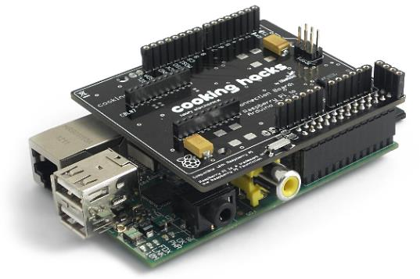 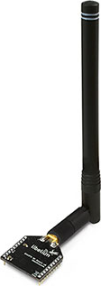

## Software configurations

Read and apply all the necessary commands descripted in the “Raspberry Configuration Tutorial: Software configuration of the Shield”.

Then you are ready to communicate over the serial port with the XBee module and test it.

## Node-RED installation and configuration (not functional now!)

For the Node-Red installation on Raspberry Pi, you must read and apply commands descripted in the “Raspberry Configuration Tutorial / Node-RED installation”.

Currently, we don’t have any solution to get messages from LoRa in Node-RED environment. We need a node to address SPI interface (LoRa don’t use the UART interface) and a library to activate, deactivate, code and decode message received or sent by the LoRa module.

The idea, to achieve this, would be to write a daemon receiving and or sending LoRa messages and send them to the UART interface to grab them with a Node-RED serial node.

## Program

Extract the Raspberry library needed to communication with the LoRa module from GitHub with the following command:

git clone https://github.com/lavirott/arduPi.git

Then go the folder arduPi/examples/LoRa and compile one program with the help of the cook script.

./cook.sh SX_01b_RX_LoRa.cpp

sudo ./ SX_01b_RX_LoRa.cpp

This program configures the LoRa module to receive messages from another module. It will wait until it receives any message from another module.

# Arduino as a Thing

## Hardware

Now, we will configure an Arduino to communicate throw an LoRa module. We use the following hardware: “[Multiprotocol Radio Shield for Arduino](https://www.cooking-hacks.com/multiprotocol-radio-shield-board-for-arduino-rpi-intel-galileo)” and of course a “[SX1272 LoRa module](https://www.cooking-hacks.com/sx1272-lora-module-for-arduino-raspberry-pi-intel-galileo-868-mhz)”. You can find a [tutorial made by Cooking Hacks](https://www.cooking-hacks.com/documentation/tutorials/extreme-range-lora-sx1272-module-shield-arduino-raspberry-pi-intel-galileo/) who sells the multiprotocol shield for Arduino. You can find 900MHz modules (for US) and 868MHz (for EU). So, we will use the last ones.

Be careful not to use the SX1272 LoRa module without the antenna. As mentioned on the Cooking Hacks website, “*It is not recommended to work without an antenna screwed to the module. The module could be damaged due to RF reflections.* ».

Connect the SX1272 LoRa module to **Socket 1** of the Multiprotocol Shield. Moreover, le SX1272 LoRa module is not compatible with the XBee shield.

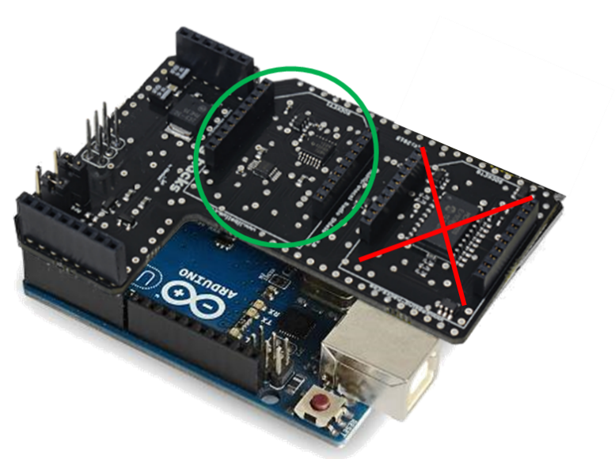

## Software configurations

First, you need to download the Arduino IDE for your operating system. We won’t detail this in this tutorial. Then you must [download the library to manage the multiprotocol shield](http://www.cooking-hacks.com/media/cooking/images/documentation/multiprotocol_radio_shield/multiprotocol_shield_library.zip). Copy the two folders MCP23008 and Multiprotocol Shield in your Arduino libraries folder (on Windows, it’s in Documents\Arduino\libraries).

Download and install the [LoRa library for Arduino](http://www.cooking-hacks.com/media/cooking/images/documentation/tutorial_SX1272/SX1272_library_arduino_v1.4.zip) in the Arduino IDE libraries folder.

## Program

This library also provides samples. To test one of these samples, go to “File / Examples / arduinoLora” and test one of them (SX_01a_TX_LoRa, for instance)

# Conclusion

With this tutorial, you learned own to make LoRa communications from Arduino (with your own program) to a Raspberry Pi (using node-RED). We hope you enjoyed!